**Initial SolidWorks Design**

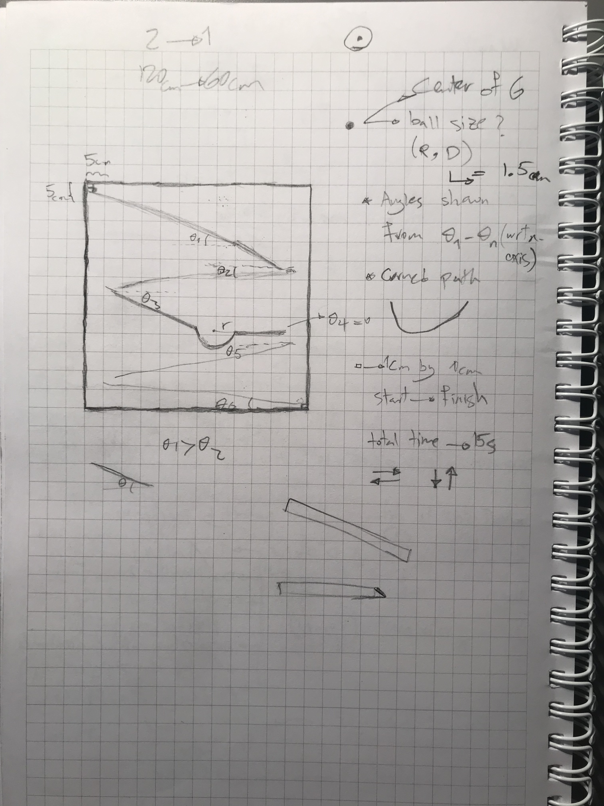   Initial design of SolidWorks was done before the physical project was built. Since we only knew the theory behind the project and how the ball is supposed to move, a rough sketch was drawn on the paper (see figure 1), then the initial SolidWorks design was made.

(Figure 1)

5 concepts were considered for the initial design:

1. The ball’s initial position must be top left of the board, and its final must be bottom right (looking from the front view).
2. Ball must move both from right to left and left to right (at least once) during its movement from start to finish
3. Ball must move down (directing of gravity force) and up (at least once) during its movement from start to finish
4. There must exist at least one curved path in the design
5. Most importantly, duration of ball movement from initial to finial position on the board must be as close as possible to 15 seconds.

Note that for the initial design, point #5 above is impossible to consider for Solidworks design since our group did not have equations required to find the time mathematically. Therefore, focus of initial design were points 1-4.

Figure 2 is our initial design made in Solidworks from isometric view. Comparing this with figure 1(rough sketch on paper), there some differences, but concepts 1-4 apply to both.

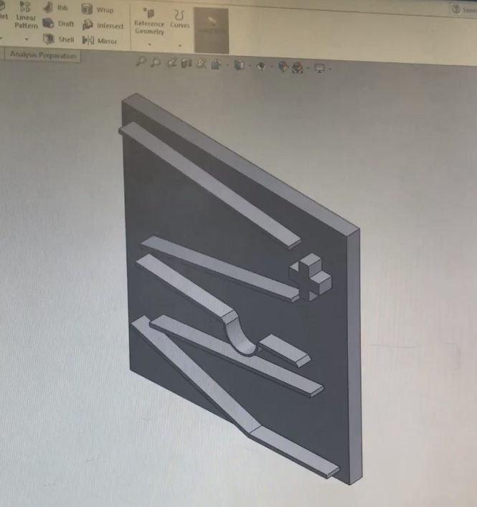(Figure 2)

Figure 3 shows how to 4 concepts above were considered in Solidworks initial design.             Numbers 1-4 represent movement from left to right (concept 2), right to left (concept 2), curved path (concept 4) and movement from down to up (concept 3), start and end position of the ball (concept 1).

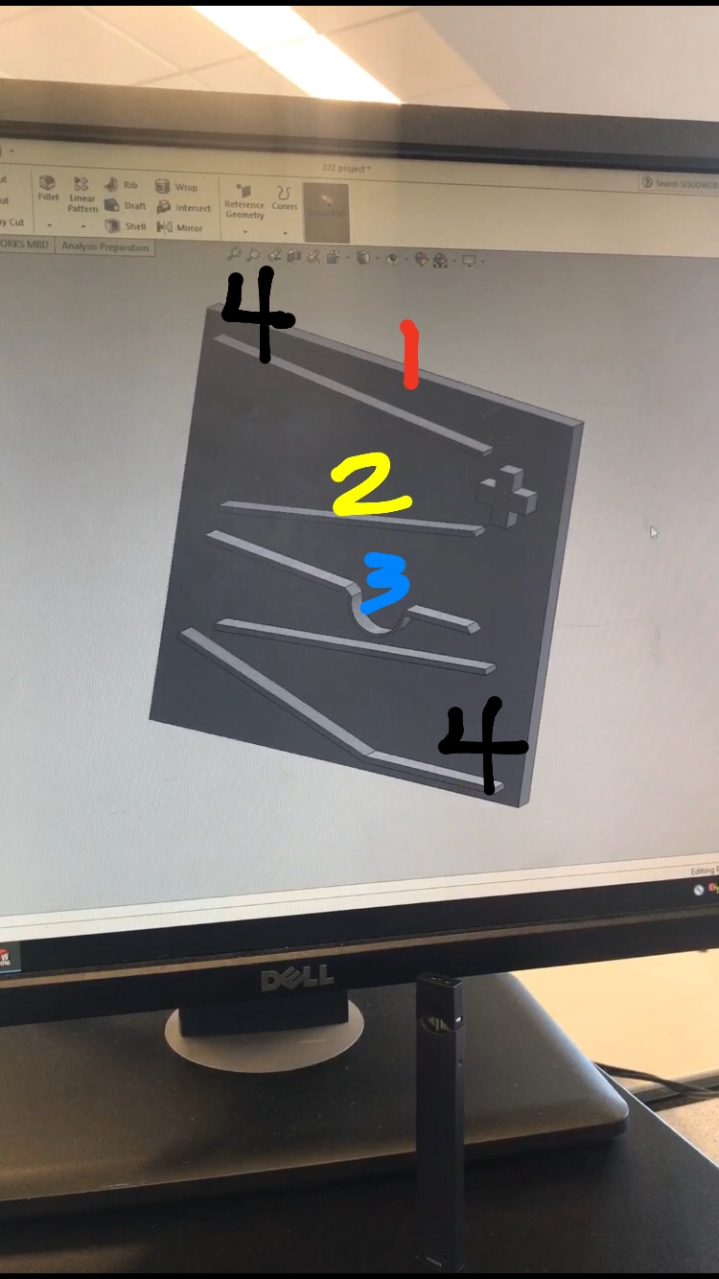

(Figure 3)

Initial design was really helpful and necessary since it gave us an idea of what the project should look like. However, as the physical project was being built, after performing multiple time testing with the ball, we realized that initial design will give have a much shorter duration that 15 seconds and it would’ve violate concept 5 (refer back to 5 concepts of initial design).

Therefore, another similar design was proposed by our group were concepts 1-4 hold true, but it was slightly different from initial design in order to meet requirement/concept #5, which was 15 seconds duration of ball movement.

Figures 4-6 show the finial solid works design from 3 different angles. As mentioned, basic concepts of ball movement are similar between both designs however there are some differences:

1. More flat paths are in the final design compare to the initial design (refer back to figure 3. note where the curved path is, the section on its its right is completely flat). Goal here was to simply increase the distance travelled by the ball to make the duration longer and closer to 15 seconds (concept #5)

2. Sloped paths have guard (refer to figure 5). In real world, ball would not move on a straight line. So, purpose of guards on sides of sloped paths is to avoid the ball from falling off.

[dimensioned drawings will be added soon]